Project Planning Phase
Project Planning Template (Product Backlog, Sprint Planning, Stories, Story points)

Date | 20 February 2025
Team ID | LTVIP2026TMIDS42531
Project Name | ShopEZ:One-Stop Shop for Online Purchases
Maximum Marks | 5 Marks

Product Backlog, Sprint Schedule, and Estimation (4 Marks)
Use the below template to create product backlog and sprint schedule
Sprint | Functional Requirement (Epic) | User Story Number | User Story / Task | Story Points | Priority | Team Members
Sprint-1 | Registration | USN-1 | As a user, I can register using email & password. | 3 | High | Thathireddy Lokitha
Sprint-1 | Registration | USN-2 | As a user, I receive confirmation email after registration. | 2 | High | Yadavakunta Pradeep Reddy
Sprint-1 | Login | USN-3 | As a user, I can login using email & password. | 2 | High | Thathireddy Lokitha
Sprint-1 | Dashboard | USN-4 | As a user, I can view product listings. | 3 | High | M Sai Dhiraj Kumar
Sprint-1 | Product Management | USN-5 | As admin, I can add products. | 3 | High | Yadavakunta Pradeep Reddy
Sprint-1 | Product Management | USN-6 | As admin, I can update/delete products. | 3 | Medium | M Sai Dhiraj Kumar
Sprint-2 | Cart Management | USN-7 | As a user, I can manage cart items. | 3 | High | Thathireddy Lokitha
Sprint-2 | Order Management | USN-8 | As a user, I can place an order. | 3 | High | Yadavakunta Pradeep Reddy
Sprint-2 | Payment Integration | USN-9 | As a user, I can make secure payment using Razorpay. | 5 | High | M Sai Dhiraj Kumar
Sprint-2 | Order Tracking | USN-10 | As a user, I can view order status. | 2 | Medium | Thathireddy Lokitha

Project Tracker, Velocity & Burndown Chart: (4 Marks)
Sprint | Total Story Points | Duration | Sprint Start Date | Sprint End Date (Planned) | Story Points Completed | Sprint Release Date (Actual)
Sprint-1 | 16 | 6 Days | 01 Feb 2025 | 06 Feb 2025 | 16 | 06 Feb 2025
Sprint-2 | 18 | 6 Days | 08 Feb 2025 | 13 Feb 2025 | 18 | 13 Feb 2025

Velocity:

- Total completed points = 16 + 18 = 34
- Number of sprints = 2
- Team velocity = 34 / 2 = 17 story points per sprint

Average Velocity per Day:

- Assuming sprint duration = 6 days
- AV per day = 17 / 6 = 2.83 story points/day
- If target velocity is 18 per sprint=18 / 6 = 3 story points/day

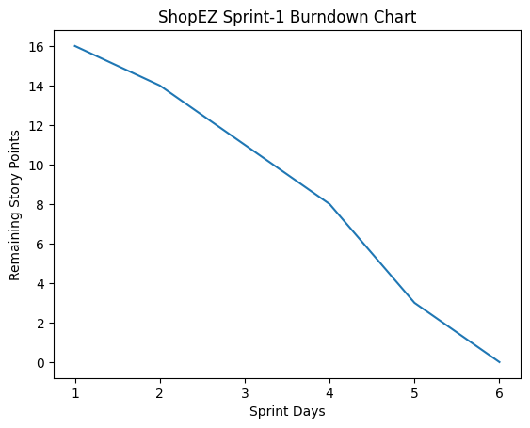
Burndown Chart:
